
Symbiosis Institute of Technology, Pune
Faculty of Engineering
CSE- Academic Year 2026-27
Java Programming – Lab Batch 2025-29
Lab Assignment No:- 23
Name of Student | Aarushi Raizada
PRN No. | 25070122002
Batch | 2025-29
Class | A1
Academic Year & Semester | 2026 SEM III
Date of Submission | 10/10/26
Title of Assignment: | Develop a Java application using JDBC to navigate and retrieve records from a ResultSet.
Theory  Practice questions | A ResultSet object contains data retrieved from a database after executing a SELECT query. It acts like a cursor that points to one row of the result at a time. Initially, the cursor is positioned before the first row. Various methods such as next(), previous(), first(), last(), absolute(), and relative() allow movement through the records. Data from each column can be retrieved using methods like getString(), getInt(), and getDouble(). Scrollable and updatable ResultSets provide greater flexibility for navigating and modifying retrieved data. ResultSet plays a crucial role in displaying and processing database information in Java applications.  1. Create a program to display database records one by one using ResultSet.  import java.sql.*;  class DisplayRecords {  public static void main(String[] args) {  try {  Connection con = DriverManager.getConnection(  "jdbc:mysql://localhost:3306/student",  "root", "your_password"  );  Statement st = con.createStatement();  ResultSet rs = st.executeQuery("SELECT * FROM student");  while (rs.next()) {  System.out.println("ID: " + rs.getInt("id"));  System.out.println("Name: " + rs.getString("name"));  System.out.println("Marks: " + rs.getInt("marks"));  System.out.println("------------------");  }  con.close();  } catch (Exception e) {  System.out.println(e);  }  }  }  CREATE DATABASE student;  USE student;  CREATE TABLE student (  id INT,  name VARCHAR(50),  marks INT  );  INSERT INTO student VALUES  (1, 'Aarav', 85),  (2, 'Riya', 90),  (3, 'Rahul', 78);  2. Create a Java program that retrieves employee records from a database and displays them one by one using ResultSet. Show employee ID, name, department, and salary sequentially  import java.sql.*;  class EmployeeRecords {  public static void main(String[] args) {  try {  Connection con = DriverManager.getConnection(  "jdbc:mysql://localhost:3306/company",  "root", "your_password"  );  Statement st = con.createStatement();  ResultSet rs = st.executeQuery("SELECT * FROM employee");  while (rs.next()) {  System.out.println("Employee ID: " + rs.getInt("emp_id"));  System.out.println("Name: " + rs.getString("name"));  System.out.println("Department: " + rs.getString("department"));  System.out.println("Salary: " + rs.getDouble("salary"));  System.out.println("----------------------");  }  con.close();  } catch (Exception e) {  System.out.println(e);  }  }  }  CREATE DATABASE company;  USE company;  CREATE TABLE employee (  emp_id INT,  name VARCHAR(50),  department VARCHAR(50),  salary DOUBLE  );  INSERT INTO employee VALUES  (101, 'Amit', 'IT', 45000),  (102, 'Priya', 'HR', 40000),  (103, 'Rahul', 'Finance', 50000);
Output Screenshots (if applicable) | Ans1  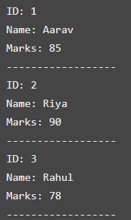  Ans 2  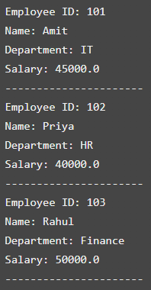
Conclusion | Thus, we successfully retrieved database records using JDBC and displayed them sequentially with the help of ResultSet and the while(rs.next()) loop.

